**Atul Anurag**

**PES2UG19CS075**

**COMPUTER NETWORKS LAB**

**Week 10**

**IPv6 Configuration and Static Routing**

**Learning Objectives:**

* Perform basic IPv6 configurations on a Desktop and Router.
* Distinguish between IPv4 and IPv6 addresses - Configure IPv6 static routes in Router - Observe traffic flow using IPv6 static routes.
* IPv6 neighbour cache entries
* Understanding IPv6 Link Local Address
* Working with ping6 and tracepath6

**LAB Network Topology:**

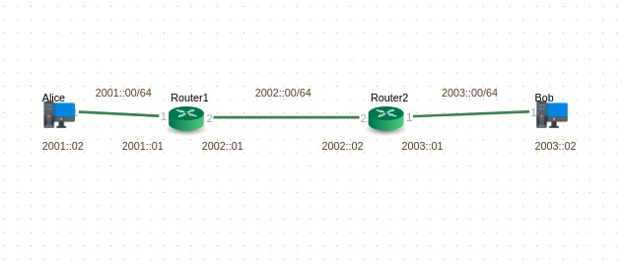

**Steps :**

1. Create and deploy the given topology.

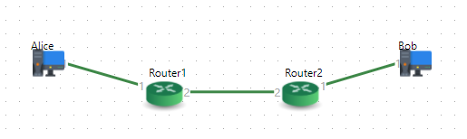

1. Configure the PC/Workstation IP address as mentioned in topology.

***Alice***

*IPv6 address – 2001::02/64 , Gateway – 2001::01*

# ***Bob***

*IPv6 address – 2003::02/64 , Gateway – 2003::01*

*Example :*

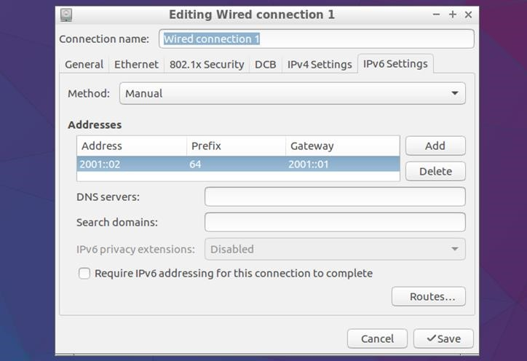

3. Enable IPv6 in Router-1

operational> configure

Entering configuration mode with exclusive access. configure> modify parameter-group router data Info: Parameter group instance loaded for modification.

configure> set ipv6 enable yes configure> save

Info: Parameter group router "data" saved

configure>

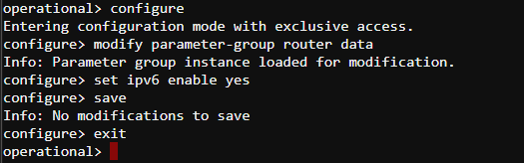

Check IPv6 information in router details

# operational> show router details data

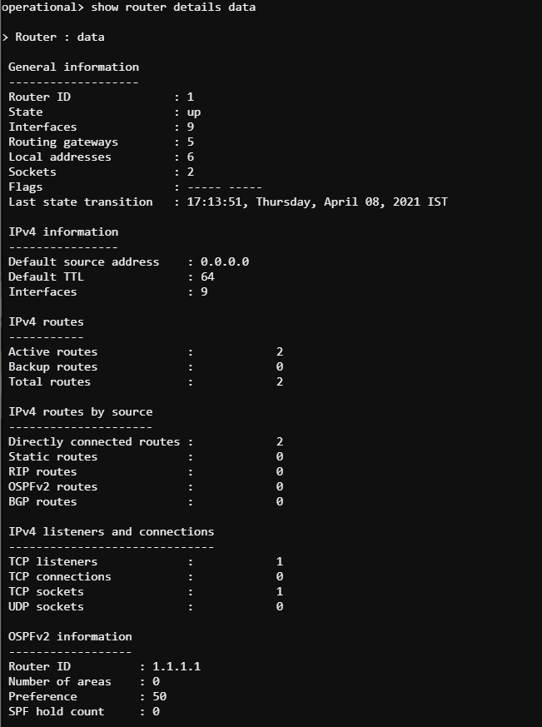

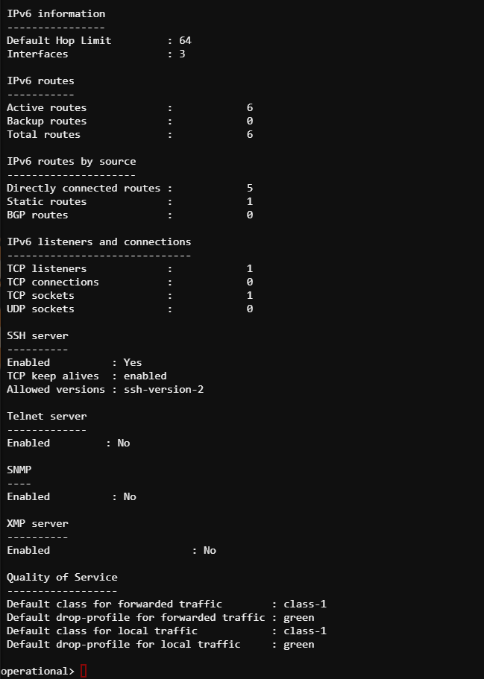

4. Configure IPv6 interfaces in Router-1

* Configure IPv6 global address 2001::01/64 to interface if-port-1

operational> configure

Entering configuration mode with exclusive access.

configure> modify parameter-group interface if-port-1

Info: Parameter group instance loaded for modification.

configure> default ip ipv4 configure> enter ip ipv6

[ interface:"if-port-1" > ip > ipv6 ] configure> show draft -e

[ interface:"if-port-1" > ip > ipv6 ] enable no

address 0000:0000:0000:0000:0000:0000:0000:0000 netmask 0000:0000:0000:0000:0000:0000:0000:0000 peer-address 0000:0000:0000:0000:0000:0000:0000:0000 peer-netmask 0000:0000:0000:0000:0000:0000:0000:0000 link-local-address 0000:0000:0000:0000:0000:0000:0000:0000 link-local-netmask 0000:0000:0000:0000:0000:0000:0000:0000 preference 1 metric 1 ndp {

cache-timeout 1200 unsolicited-learning enable

} vrrp { enable no

virtual-router [+] {

}

}

configure> set enable yes configure> set address 2001::01/64

configure> save

Info: Parameter group interface "if-port-1" saved configure>

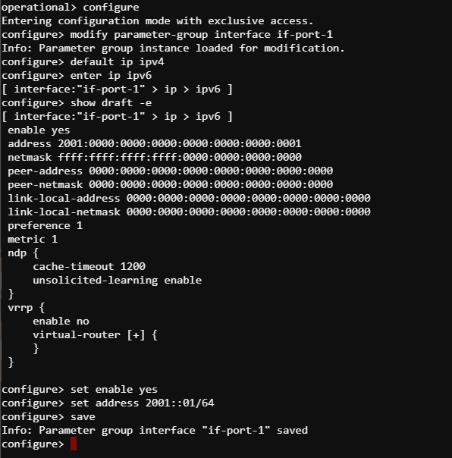

## * Configure IPv6 global address 2002::01/64 to interface if-port-2

configure> modify parameter-group interface if-port-2

Info: Parameter group instance loaded for modification.

configure> default ip ipv4 configure> set ip ipv6 enable yes configure> set ip ipv6 address 2002::01/64 configure> save

Info: Parameter group interface "if-port-2" saved configure> exit

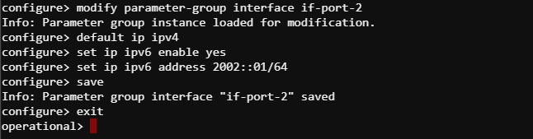

## * Verify Interface configurations

operational> show interface all

Interface name Status Encaps- IP address ulation

------------------------------------------------------------------------------ if-port-1 up ethernet 2001::1/64

fe80::226:f7ff:fe00:6d/64 if-port-2 up ethernet 2002::1/64

fe80::226:f7ff:fe00:6e/64 if-port-3 down ethernet - if-port-4 down ethernet - if-port-5 down ethernet - if-port-6 down ethernet - if-port-7 down ethernet - if-port-8 down ethernet -

management disabled ethernet 10.0.0.12/24

Total number of interfaces displayed : 9

operational>

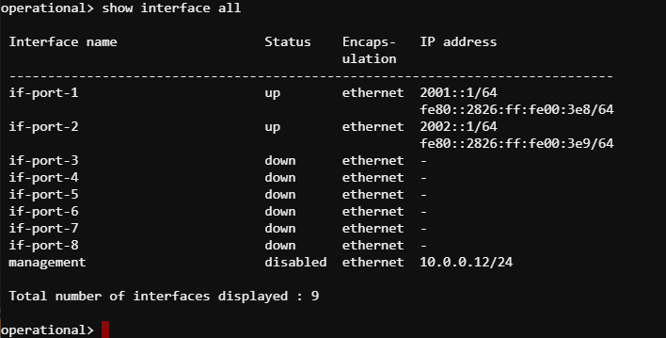

Check IPv6 information in “show interface details” command output

operational> show interface details if-port-1 if-port-2

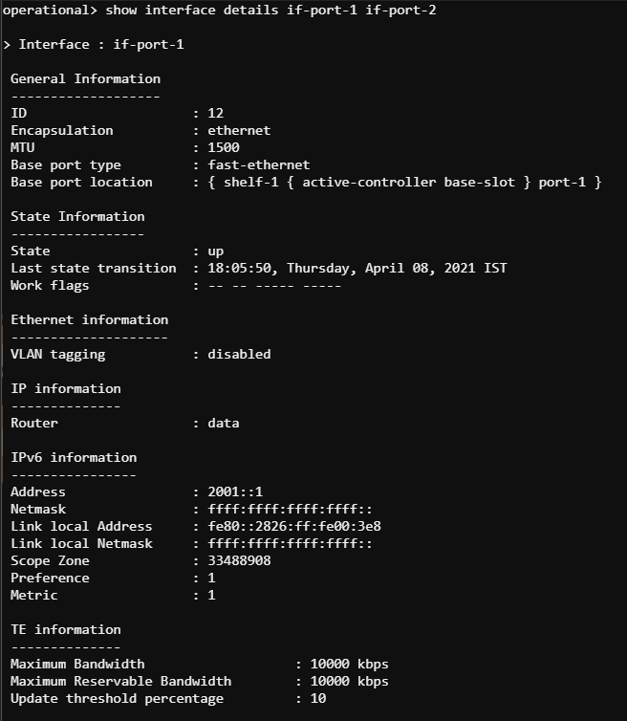

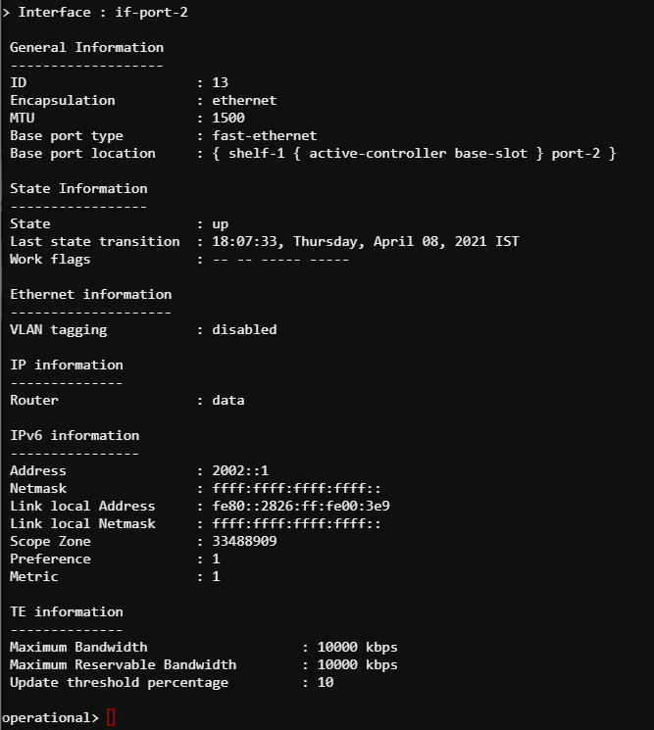

5. Configure IPv6 static routes in Router-1

## * Configure a static route to reach 2003:00/64 network (Bob) with gateway as 2002::02( Router-2)

operational> configure

Entering configuration mode with exclusive access.

configure> create parameter-group ip-route v6-route-2003-nw

Info: Parameter group instance created. configure> show draft -e [ ip-route:"v6-route-2003-nw" ] *name "v6-route-2003-nw" enable no router "" destination 0.0.0.0 netmask 0.0.0.0 next-hop { router "" gateway 0.0.0.0 label-switched-path ""

}

preference 30 metric 2 configure> set enable yes configure> set router data configure> set destination 2003::/64 configure> set next-hop gateway 2002::02 configure> save

Info: Parameter group ip-route "v6-route-2003-nw" saved configure> configure>

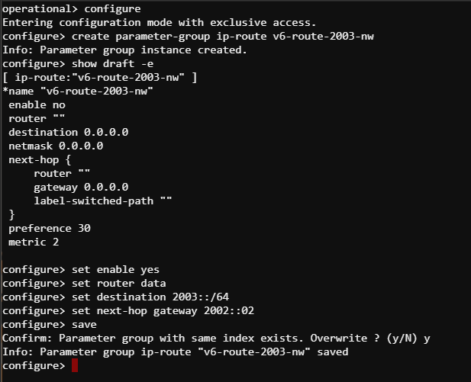

6. Display IPv6 routing table in Router-1

The configured static route should appear in the IPv6 routing table

operational> show route summary -F ipv6 data

> IPv6 active routes

>> Destination : ::1/128

Gateway(s) : { ^loopback-16387

::1 }

Source : direct

Flags : -

>> Destination : 2001::/64

Gateway(s) : { if-port-1

:: }

Source : direct

Flags : -

>> Destination : 2002::/64

Gateway(s) : { if-port-2

:: }

Source : direct

Flags : -

>> Destination : 2003::/64

Gateway(s) : { if-port-2

2002::2 }

Source : static

Flags : -

>> Destination : fe80::/64

Gateway(s) : { if-port-1

:: }

Source : direct

Flags : -

>> Destination : fe80::/64

Gateway(s) : { if-port-2

:: }

Source : direct

Flags : -

Total number of IPv6 active routes displayed : 6 No IPv6 backup routes are available operational>

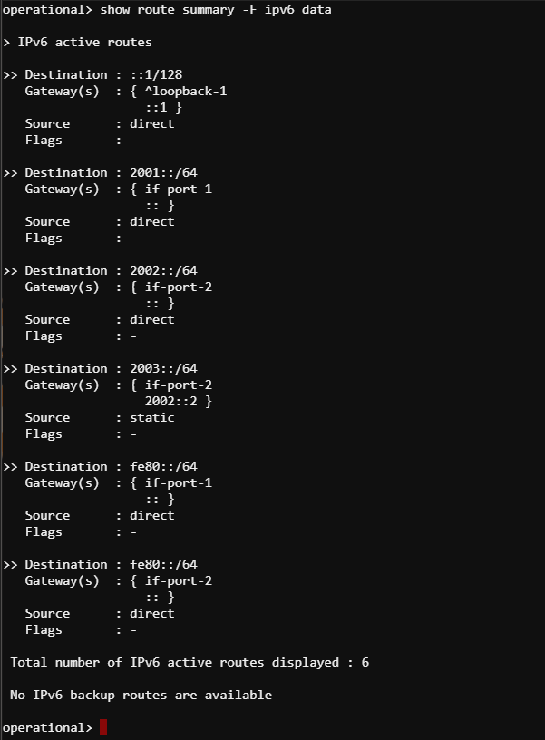

7. Enable IPv6 in Router-2

operational> configure

Entering configuration mode with exclusive access. configure> modify parameter-group router data Info: Parameter group instance loaded for modification.

configure> set ipv6 enable yes configure> save

Info: Parameter group router "data" saved configure>

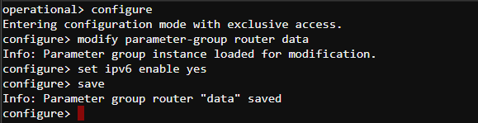

Check IPv6 information in router details

operational> show router details data

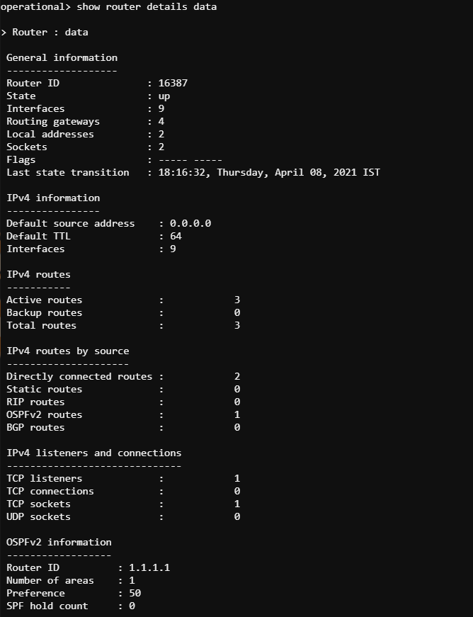

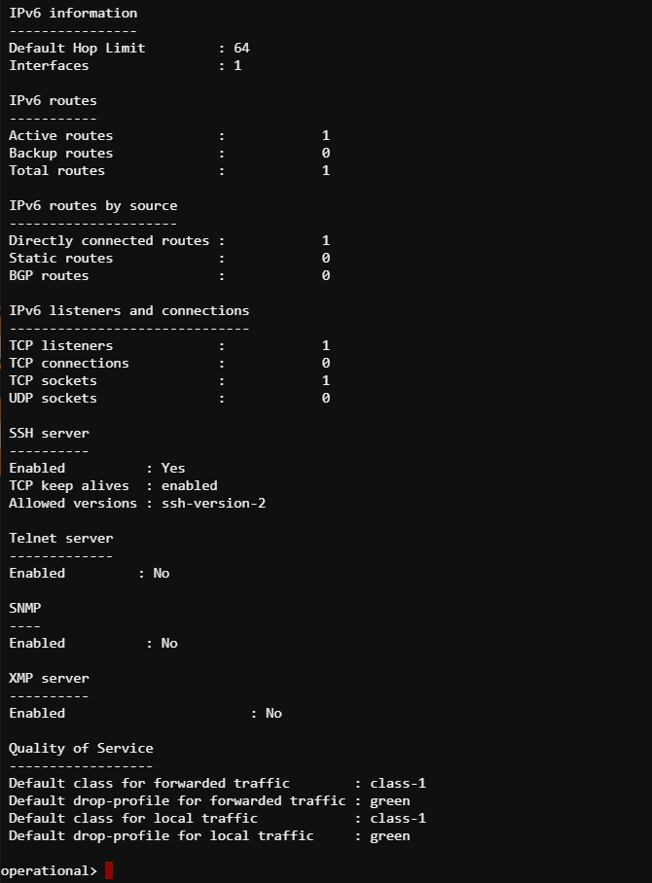

8*.* Configure IPv6 interfaces in Router-2

## * Configure IPv6 global address 2003::01/64 to interface if-port-1

configure> modify parameter-group interface if-port-1Info: Parameter group instance loaded for modification.

configure> default ip ipv4 configure> set ip ipv6 enable yes configure> set ip ipv6 address 2003::01/64configure> save

Info: Parameter group interface "if-port-1" savedconfigure> exit

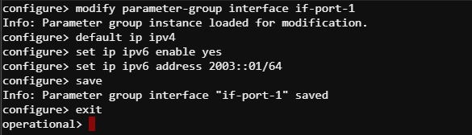

## * Configure IPv6 global address 2002::02/64 to interface if-port-2

configure> modify parameter-group interface if-port-2

Info: Parameter group instance loaded for modification. configure> default ip ipv4 configure> set ip ipv6 enable yes configure> set ip ipv6 address 2002::02/64configure> save

Info: Parameter group interface "if-port-2" saved

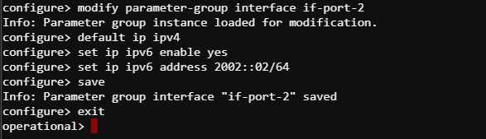

## * Verify Interface configurations

operational> show interface all

Interface name Status Encaps- IP address ulation

------------------------------------------------------------------------------ if-port-1 up ethernet 2003::1/64

fe80::226:f7ff:fe00:76/64 if-port-2 up ethernet 2002::2/64

fe80::226:f7ff:fe00:77/64 if-port-3 down ethernet - if-port-4 down ethernet - if-port-5 down ethernet - if-port-6 down ethernet - if-port-7 down ethernet - if-port-8 down ethernet -

management disabled ethernet 10.0.0.12/24

Total number of interfaces displayed : 9 operational>

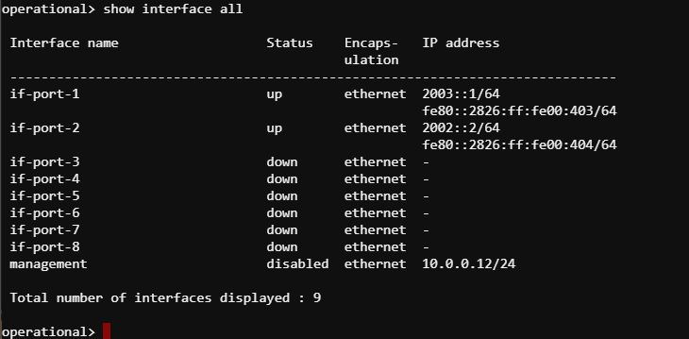

Check IPv6 information in “show interface details” command output

operational> show interface details if-port-1 if-port-2

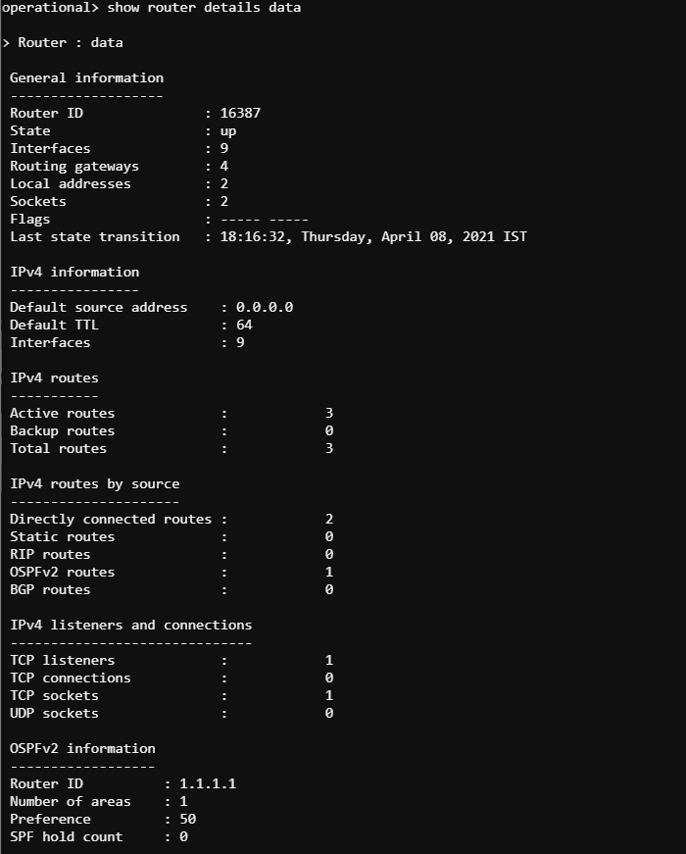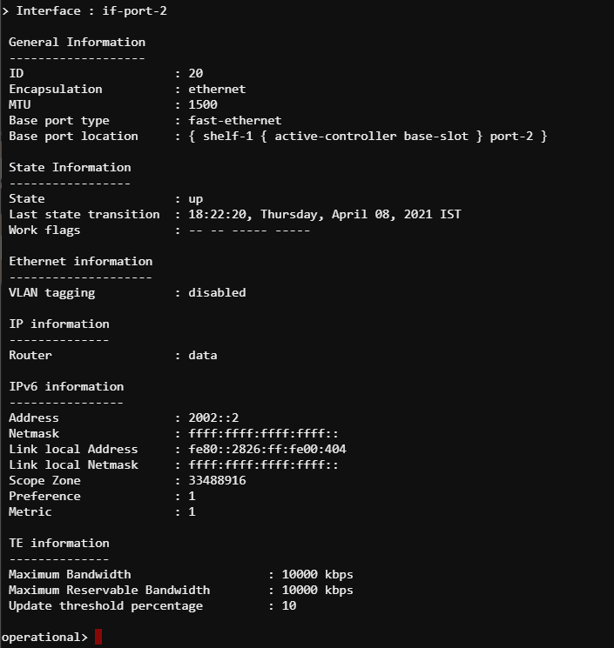

9. Configure IPv6 static route in Router-2

## * Configure a static route to reach 2001:00/64 network (Alice) with gateway as 2002::01( Router-1)

operational> configure

Entering configuration mode with exclusive access.

configure> create parameter-group ip-route v6-route-2001-nw

Info: Parameter group instance created. configure> show draft -e

[ ip-route:"v6-route-2001-nw" ]*name "v6-route-2001-nw" enable no router "" destination 0.0.0.0 netmask 0.0.0.0 next-hop { router "" gateway 0.0.0.0 label-switched-path ""

} preference 30 metric 2

configure> set enable yes configure> set router data configure> set destination 2001::/64configure> set next-hop gateway 2002::01

configure> save

Info: Parameter group ip-route "v6-route-2001-nw" savedconfigure> show draft -e [ ip-route:"v6-route-2001-nw" ] *name "v6-route-2001-nw" enable yes router "data"

destination 2001:0000:0000:0000:0000:0000:0000:0000 netmask ffff:ffff:ffff:ffff:0000:0000:0000:0000 next-hop { router ""

gateway 2002:0000:0000:0000:0000:0000:0000:0001 label-switched-path ""

} preference 30 metric 2

configure>

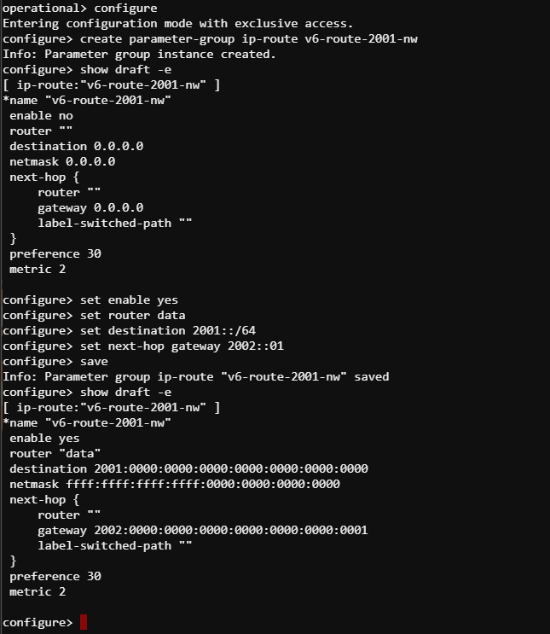

10. Display IPv6 routing table in Router-2

operational> show route summary -F ipv6 data

> IPv6 active routes

>> Destination : ::1/128

Gateway(s) : { ^loopback-16387

::1 }

Source : direct

Flags : -

>> Destination : 2001::/64

Gateway(s) : { if-port-2

2002::1 }

Source : static

Flags : -

>> Destination : 2002::/64

Gateway(s) : { if-port-2

:: }

Source : direct

Flags : -

>> Destination : 2003::/64

Gateway(s) : { if-port-1

:: }

Source : direct

Flags : -

>> Destination : fe80::/64

Gateway(s) : { if-port-1

:: }

Source : direct

Flags : -

>> Destination : fe80::/64

Gateway(s) : { if-port-2

:: }

Source : direct

Flags : -

Total number of IPv6 active routes displayed : 6 No IPv6 backup routes are available operational>

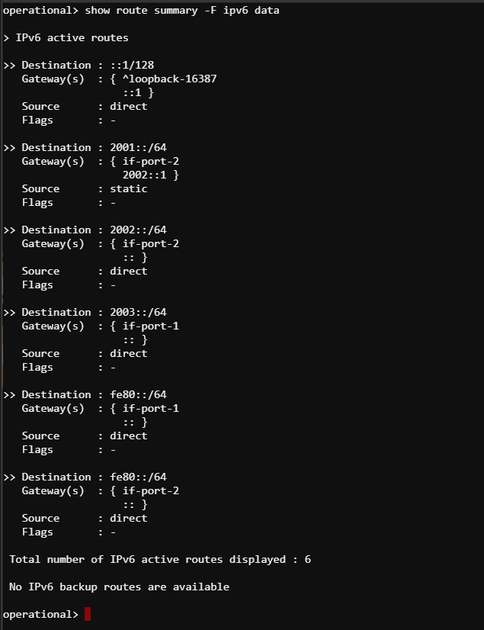

11. Verify traffic flow between Alice and Bob

* From Alice workstation ping Bob, observe the packet from and TTL in ping reply

* From Alice workstation run tracepath to Bob’s IP. Observer the intermediate hops

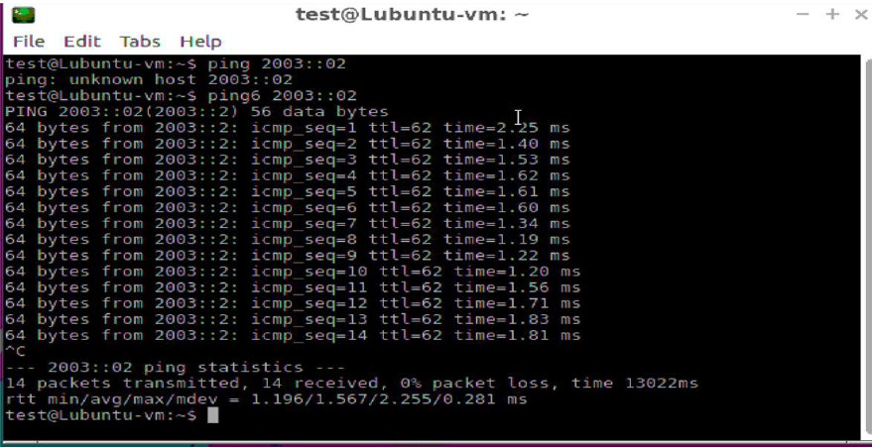

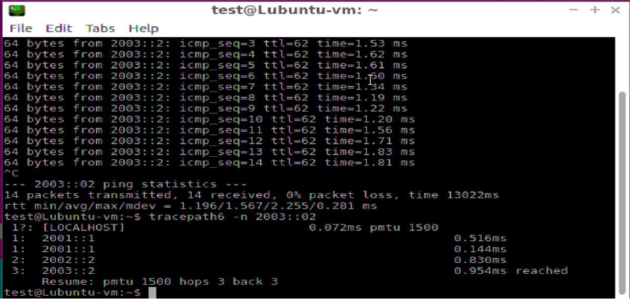

1. Check IPv6 NDP table on Router-1

This is similar to ARP Table in IPv4.

operational> show ipv6 neighbour summary data

Host address MAC address Interface

-------------------------------------------------------------------------------

2002::1 00:26:f7:00:00:6e if-port-2 2003::2 00:26:f7:00:09:3c if-port-1 fe80::226:f7ff:fe00:6e 00:26:f7:00:00:6e if-port-2 fe80::5d97:cf2f:4a3:d8cb 00:26:f7:00:09:3c if-port-1

Total number of NDP entries displayed : 4

operational>

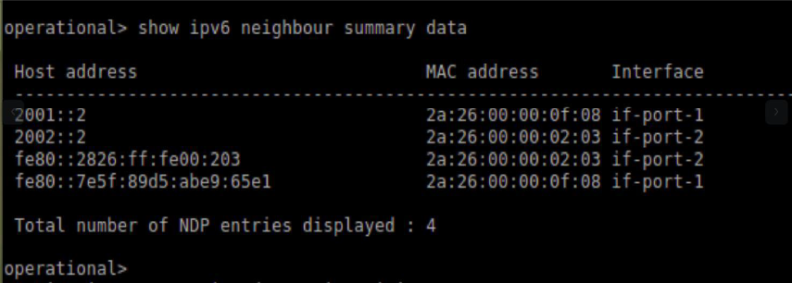

1. Verify auto-configured Link Local Address on IPv6 interfaces

All IPv6 enabled interfaces will have a link-local address. IPv6 link-local address is a unicast address that is configured automatically using the prefix FE80::/10 and port MAC in the modified EUI-64 format. The linklocal address can also be manually configured.

Link-local addresses are used for a addressing on a single physical link. These addresses can be used to reach the neighboring nodes attached to the same link. Routers will not forward packets using link-local addresses.

Two routers can have same link-local address and can still communicate over directly connected network. But, the global unicast address should be unique in a network as they are routable.

Login to Router-1 and check the auto-configured link local address.

For Example :

operational> show interface details if-port-1

> Interface : if-port-1

General Information

-------------------

ID : 21

Encapsulation : ethernet

MTU : 1500

Base port type : fast-ethernet

Base port location : { shelf-1 { active-controller base-slot } port-1 }

State Information

-----------------

State : up

Last state transition : 15:19:44, Monday, March 18, 2019 IST

Work flags : -- -- ----- -----

Ethernet information

--------------------

VLAN tagging : disabled

IP information

--------------

Router : data

IPv6 information

----------------

Address : 2001::1

Netmask : ffff:ffff:ffff:ffff::

Link local Address : fe80::226:f7ff:fe00:6d <====== Combination of FE08 and port MAC

Link local Netmask : ffff:ffff:ffff:ffff::

Scope Zone : 33488917

Preference : 1

Metric : 1

TE information

--------------

Maximum Bandwidth : 10000 kbps

Maximum Reservable Bandwidth : 10000 kbps

Update threshold percentage : 10

operational>

operational> show fast-ethernet details { shelf-1 { active-controller base-slot } port-1 }

> Port : { shelf-1 { active-controller base-slot } port-1 } Port details

------------

Name :

MAC address : 00:26:f7:00:00:6d <=============

POST : passed

Media : copper

Loop back mode : no-loopback

State : up

Duplex mode : half-duplex

Speed : ten-mbps Work flags : ---- ---- operational>

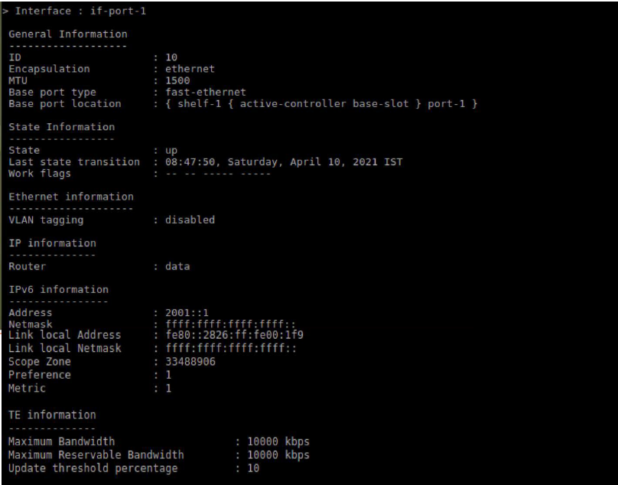

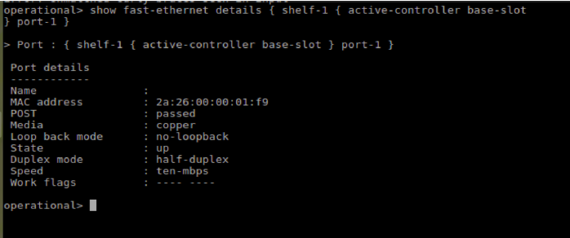

14. Check the connectivity between Router-1 and Router-2 using Link Local Address

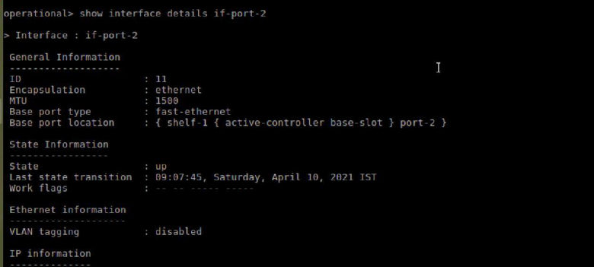

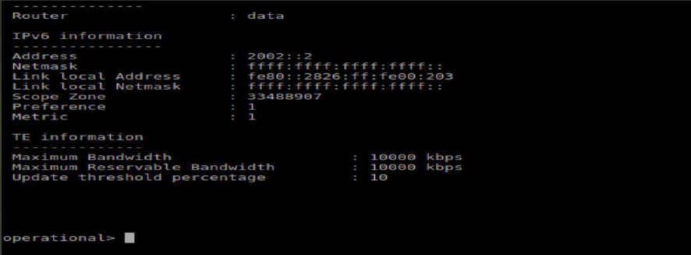

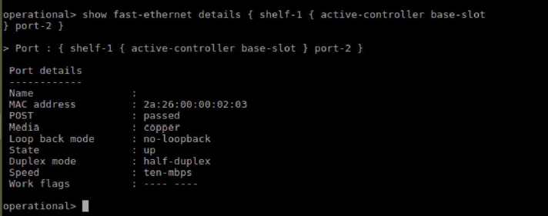

Login to Router-2 and get the link-local address of interface connected to Router-1.

Now, Login to Router-1 and ping the link-local address on Router-2 and observe the response. When pinging link-local address, the the name if out-going interface should be specified in the command. If no interface or wrong interface name is specified, ping will result in error or unsuccessful.

